Activity | Data Type
Number of beatings from Wife | numeric-discrete
Results of rolling a dice | Numeric-discrete
Weight of a person | numeric-continuous
Weight of Gold | numeric-continuous
Distance between two places | numeric-continuous
Length of a leaf | numeric-continuous
Dog's weight | numeric-continuous
Blue Color | categorical-nominal
Number of kids | Numeric-discrete
Number of tickets in Indian railways | numeric-discrete
Number of times married | numeric-discrete
Gender (Male or Female) | Categorical-nominal
Q1) Identify the Data type for the Following:

Q2) Identify the Data types, which were among the following
Nominal, Ordinal, Interval, Ratio.
Data | Data Type
Gender | nominal
High School Class Ranking | ordinal
Celsius Temperature | interval
Weight | ratio
Hair Color | nominal
Socioeconomic Status | ordinal
Fahrenheit Temperature | Interval
Height | ratio
Type of living accommodation | nominal
Level of Agreement | ordinal
IQ(Intelligence Scale) | interval
Sales Figures | ratio
Blood Group | nominal
Time Of Day | interval
Time on a Clock with Hands | interval
Number of Children | ratio
Religious Preference | nominal
Barometer Pressure | interval
SAT Scores | interval
Years of Education | ratio

Q3) Three Coins are tossed, find the probability that two heads and one tail are obtained?
A)Three cases : HHT HTH THH
3/8=37.5%
Q4) Two Dice are rolled, find the probability that sum is
- Equal to 1
- Less than or equal to 4
- Sum is divisible by 2 and 3
A)a)0/36
b)the cases are:(1,3),(2,2),(3,1),(1,2),(2,1),(1,1)
probability=number of cases/number of possible cases=6/36=16.67%
c)the cases are:(1,5),(2,4),(3,3),(4,2),(5,1),(6,6)
probability=number of cases/number of possible cases 6/36=16.67%
Q5) A bag contains 2 red, 3 green and 2 blue balls. Two balls are drawn at random. What is the probability that none of the balls drawn is blue?
A)(probability of first ball to be not blue)*(probability of second ball not blue)
(5/7)*(4/6)=20/42=47.62%

Q6) Calculate the Expected number of candies for a randomly selected child
Below are the probabilities of count of candies for children (ignoring the nature of the child-Generalized view)
CHILD | Candies count | Probability
A | 1 | 0.015
B | 4 | 0.20
C | 3 | 0.65
D | 5 | 0.005
E | 6 | 0.01
F | 2 | 0.120
Child A – probability of having 1 candy = 0.015.
Child B – probability of having 4 candies = 0.20
A)expectation=(1*0.015)+(4*0.20)+(3*0.65)+(5*0.005)+(6*0.01)+(2*0.120)=3.09

Q7) Calculate Mean, Median, Mode, Variance, Standard Deviation, Range & comment about the values / draw inferences, for the given dataset
- For Points,Score,Weigh>
Find Mean, Median, Mode, Variance, Standard Deviation, and Range and also Comment about the values/ Draw some inferences.
 | Mean | Median | Mode | Variance | Standard deviation | Range
Points | 3.60 | 3.695 | 3.07,3.92 | 0.29 | 0.53 | 2.170
Score | 3.22 | 3.325 | 3.440 | 0.96 | 0.98 | 3.911
Weigh | 17.85 | 17.710 | 18.90,17.02 | 3.19 | 1.79 | 8.400

Points has fairly small standard deviation.

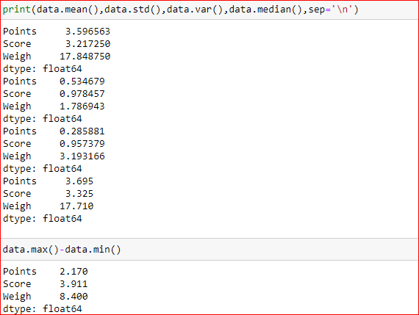

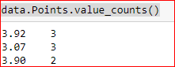

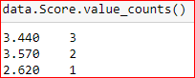

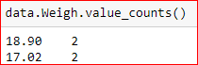

Use Q7.csv file
Q8) Calculate Expected Value for the problem below
- The weights (X) of patients at a clinic (in pounds), are
108, 110, 123, 134, 135, 145, 167, 187, 199
Assume one of the patients is chosen at random. What is the Expected Value of the Weight of that patient?
A)Expecation=(108+110+123+134+135+145+167+187+199)/9
= 145.33 pounds
Q9) Calculate Skewness, Kurtosis & draw inferences on the following data
Cars speed and distance
Use Q9_a.csv
speed: skewness=-0.12, kurtosis=-0.51 . The distribution is negatively skewed slightly and platykurtic and is close to normal distribution.
distance: skewness=0.81, kurtosis=0.41 . The distribution is positively skewed and leptokurtic and differs moderately from normal distribution.
SP and Weight(WT)
Use Q9_b.csv
SP: skewness=1.61, kurtosis=2.98 . The distribution is positively skewed heavily and is leptokurtic and is different from normal distribution in a significant way.
WT: skewness=-0.61, kurtosis=0.95 . The distribution is negatively skewed and is leptokurtic and differs from normal distribution moderately.
Q10) Draw inferences about the following boxplot & histogram

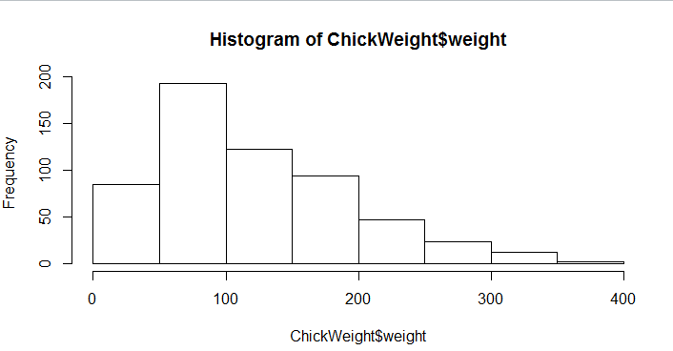

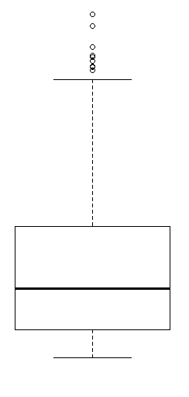
A)The data is positively skewed with a most of the values below the mean and a lot of outliers.
Q11) Suppose we want to estimate the average weight of an adult male in Mexico. We draw a random sample of 2,000 men from a population of 3,000,000 men and weigh them. We find that the average person in our sample weighs 200 pounds, and the standard deviation of the sample is 30 pounds. Calculate 94%,98%,96% confidence interval?
A) 94% confidence interval=(198.74,201.26)
96% confidence interval=(198.44,201.56)
98% confidence interval=(198.62,201.38)
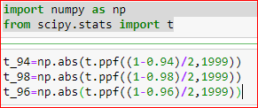

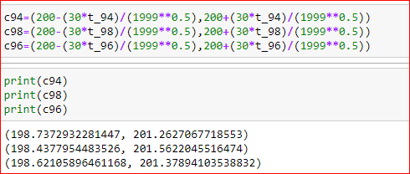

Q12) Below are the scores obtained by a student in tests
34,36,36,38,38,39,39,40,40,41,41,41,41,42,42,45,49,56
- Find mean, median, variance, standard deviation.
- What can we say about the student marks?
1)Mean=41, median=40.5, variance=24.11, standard deviation=4.91
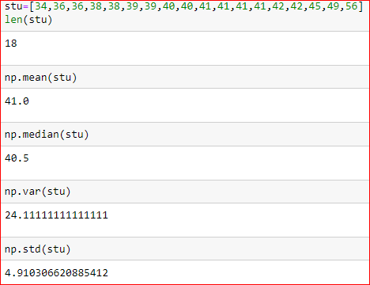

2)mean and median are very close and the standard deviation is low The data have closer values with very low skewness.
Q13) What is the nature of skewness when mean, median of data are equal?
0
Q14) What is the nature of skewness when mean > median ?
Positively skewed
Q15) What is the nature of skewness when median > mean?
Negatively skewed
Q16) What does positive kurtosis value indicates for a data ?
Leptokurtic - a steeper curve than normal distribution.
Q17) What does negative kurtosis value indicates for a data?
Platykurtic -a flatter curve than normal distribution
Q18) Answer the below questions using the below boxplot visualization.
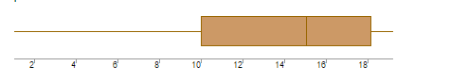
What can we say about the distribution of the data?
What is nature of skewness of the data?
What will be the IQR of the data (approximately)?
A)The data is negatively skewed with large variance
negatively skewed
IQR=8

Q19) Comment on the below Boxplot visualizations?
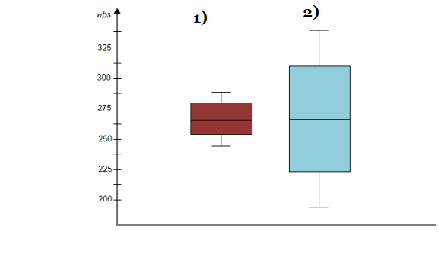
Draw an Inference from the distribution of data for Boxplot 1 with respect Boxplot 2.
A)median of both data are very close.The standard deviation and variance of boxplot 1 is much smaller than that of boxplot 2. skewness of both boxplots are close to zero with mean also equal or close.
Q 20) Calculate probability from the given dataset for the below cases

Data _set: Cars.csv
Calculate the probability of MPG of Cars for the below cases.
MPG <- Cars$MPG
  - P(MPG>38)
  - P(MPG<40)
c. P (20<MPG<50)
a)0.41
b)0.75
c)0.85
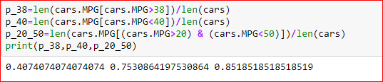

Q 21) Check whether the data follows normal distribution
- Check whether the MPG of Cars follows Normal Distribution
Dataset: Cars.csv
MPG of cars have a skewness of -0.18 and based on the density graph the data follows a normal distribution.
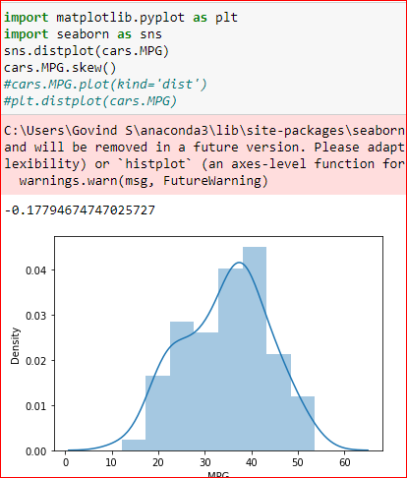

- Check Whether the Adipose Tissue (AT) and Waist Circumference(Waist) from wc-at data set follows Normal Distribution
Dataset: wc-at.csv
Adipose tissue data from the dataset wc-at has a skewness of 0.58 and doesn’t follow normal distribution from the graph.
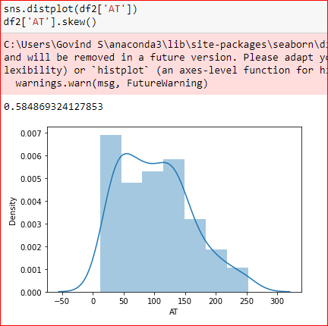

Waist data has a skewness of 0.13 and based on the graph the distribution follows normal distribution.
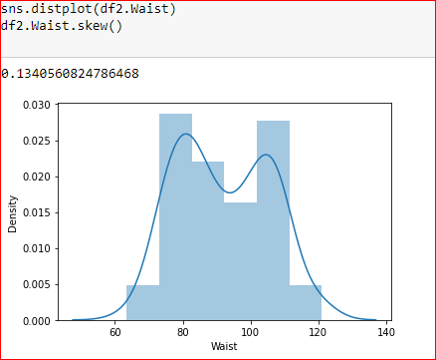

Q 22) Calculate the Z scores of 90% confidence interval,94% confidence interval, 60% confidence interval
for 90%: 1.645
94%: 1.88
60%: 0.842
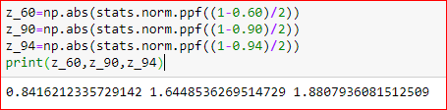

Q 23) Calculate the t scores of 95% confidence interval, 96% confidence interval, 99% confidence interval for sample size of 25
95%: 2.064
96%: 2.17
99%: 2.797
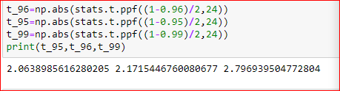

Q 24) A Government company claims that an average light bulb lasts 270 days. A researcher randomly selects 18 bulbs for testing. The sampled bulbs last an average of 260 days, with a standard deviation of 90 days. If the CEO's claim were true, what is the probability that 18 randomly selected bulbs would have an average life of no more than 260 days
Hint:
rcode → pt(tscore,df)
df → degrees of freedom

A)32.16%
